Temu data collection and management
Summary
- Temu collects information for the sole purpose of providing and enhancing its e-commerce service to users.
- Temu’s data practices are no different from other apps like Amazon or Etsy.
- Temu actually collects less user information than other apps like Amazon.
- Temu does not ask for system permissions to access things like your photos, contacts, or location.
- Temu does not sell customer data.
- Temu does not share payment details with its merchants or logistics partners. If customers use payment methods like Apple Pay or PayPal, Temu does not receive the payment details.
- The Temu app is available for download on Apple’s App Store and Google’s Play Store. Both the App Store and Google Play employ rigorous measures to ensure app integrity and user security.

Temu’s data collection practices
At Temu, we prioritize privacy protection and maintain transparency about our data practices. Our data collection has a clear and singular purpose: to provide and continually enhance our products and services for users, aligning with common industry practices.

The data categories collected by Temu include:
- Purchases & Financial info: Essential for processing and fulfilling orders.
- Location data: Generally not requested, except in the Middle East for easier shipping address completion.
- Contact info: Necessary for order fulfilment and account creation.
- User content: Enables features like photo uploads, reviews, and customer service contact. Temu only uses system-built photos for user uploads and does not request permission to read photos.
- Search history: Helps personalize user experiences by recommending relevant products or services.
- Identifier & Diagnostics & Usage data: Collected to identify accounts or devices, analyse app issues, and improve services.
For complete transparency, users can view the permissions Temu seeks on the website or app under “Settings” or at Temu Permissions. A comprehensive Privacy Policy is also available at Privacy and Cookie Policy.In line with our commitment to full transparency, every single user can also view the permissions that Temu seeks on the website or app under “Settings” or at https://www.temu.com/au/permission.html. For a deeper dive into our stance on data protection, users may also visit our comprehensive Privacy Policy at https://www.temu.com/au/privacy-and-cookie-policy.html.
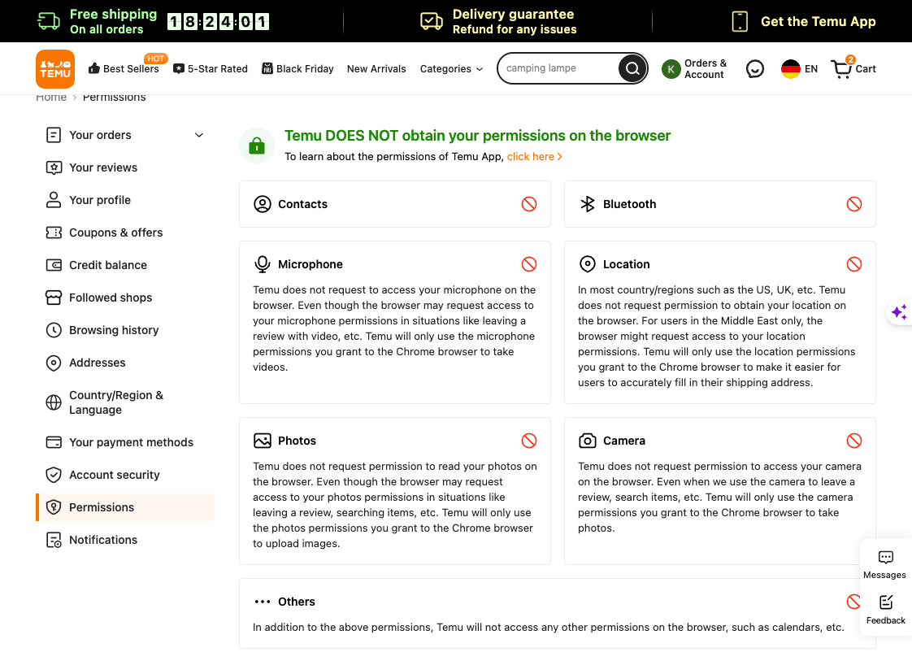
Data retention

Temu will delete the customer's account within seven business days of receiving a deletion request and will remove all customer data except for what is legally required to be retained and for other legitimate reasons. This retention is necessary for legal, regulatory, tax, security, integrity, and compliance purposes. The duration of data retention depends on the type of personal information, our purposes for processing it, and the legal obligations we are required to fulfill.
Industry practices
Temu’s data gathering practices align with that of the industry peers. For illustration, below is a snapshot of Temu’s data disclosure (left) from the Apple App Store, detailing the information we gather. Compare this with Amazon’s disclosure (right). Notably, Temu collects data from fewer categories compared to peers.

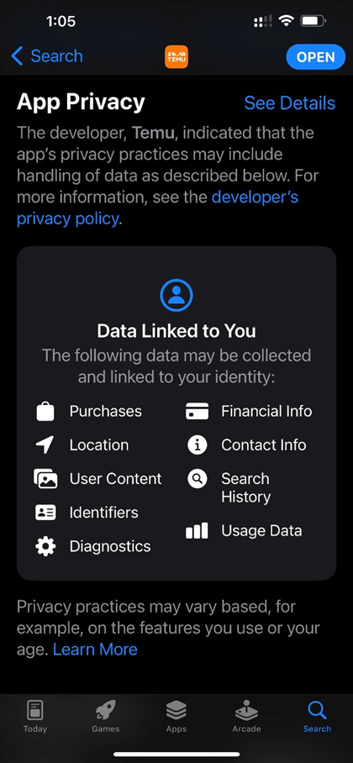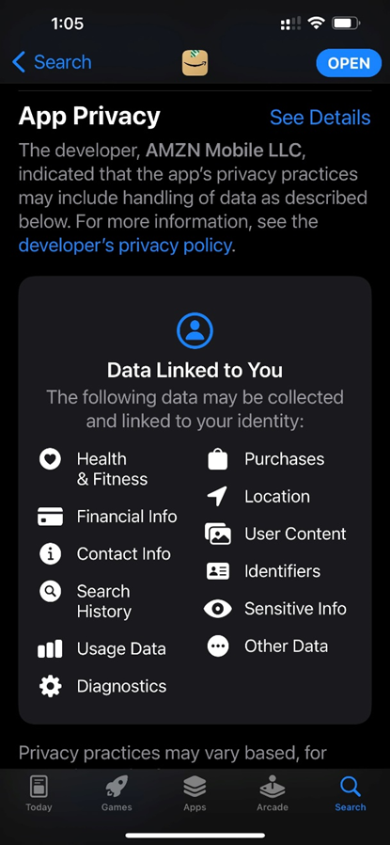

Temu’s data deletion and retention approach aligns with legal requirements and reflects standard industry practices. For your reference, we have included relevant sections from Amazon and Etsy's policies on account closure and data deletion.

Amazon
https://www.amazon.de/privacy/data-deletion
After you’ve closed your account, we will assess what information to keep. We normally choose to keep some data in line with our legal obligations, including under the Luxembourg Commercial Code, for the establishment, exercise or defence of legal claims, and for preventing fraud/ensuring security, as envisaged by the General Data Protection Regulation (GDPR). For these reasons, we normally retain transactional data related to orders of a customer for products and services, for example, customer name, ordered product, order date delivery address, payment method, price and VAT. We may also keep limited personally identifying account information following account closure in order to administer these rights and obligations.
Etsy
https://help.etsy.com/hc/en-us/articles/360021647754-Can-I-Permanently-Delete-My-Etsy-Account-
Depending on which of our services you've used (such as whether you've made purchases or sales on Etsy) or if your account violated our policies, we may be required to retain certain information for legal, regulatory, tax, security, or compliance reasons for a limited period of time, after which it will be deleted.
Temu permissions explainer
Some media and influencers have expressed concerns about Temu potentially engaging in malicious activities through the use of the camera, photos, microphone, contacts, location, and other functions. These concerns are ungrounded.
To address them, Temu has added a permissions section in the app and website, elaborating on required permissions for data minimization and transparency.

Find the “permissions” section under SETTINGS on the Temu APP or website.
<b200ea390ff2dedd342b4e65f8f69949a703d86f.png>
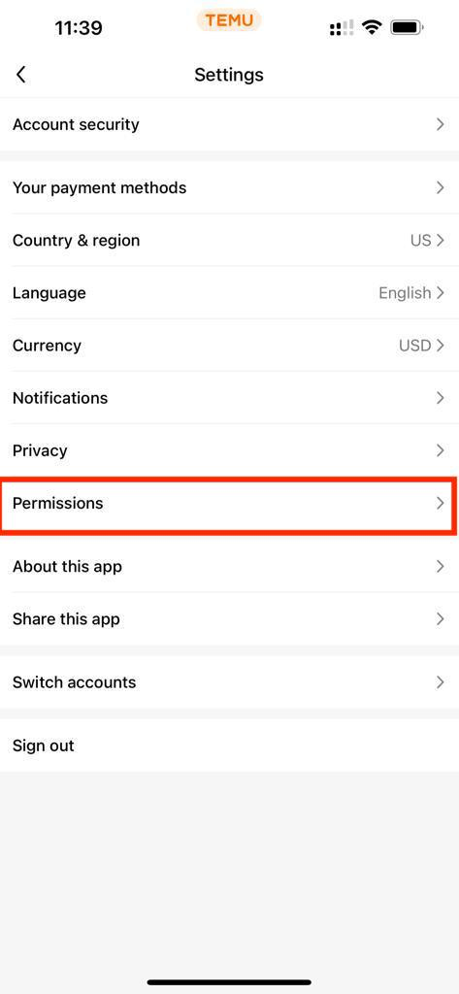
Similarly, you can find the “permissions” section under SETTINGS on the website at www.temu.com.
<af88e5ab4b4b5cec41e9551615e85b095ad28438.png>
What are app permissions, and how do they work?
Application permissions are safeguards by the phone's operating system to control app access to features or data. Temu is committed to transparency and minimal permissions usage.
When using photos for features like reviews, Temu does not directly access the camera. Instead, it delegates tasks to the phone's camera and gallery apps, ensuring user privacy.
How does the Temu app deal with permissions?
Temu is dedicated to maintaining transparency and minimizing the use of permissions within the application. Even when Temu uses the photos to leave a review, search for items, etc., Temu will not obtain system permissions directly.
For example, when the Temu app uses photos to leave a review, it doesn't directly take photos or videos. Instead, when you want to upload a photo or video, it asks your phone's built-in camera and gallery apps to do that job.

So, when you're taking a photo or choosing one, you're dealing directly with your phone's own apps. Once you're done, those photos or videos are given to the Temu app. But during this whole process, Temu isn't peeking into where you are or asking for your location. It just uses the photo or video you picked.

Temu and GPS Location
ACCESS_FINE_LOCATION acquisition is a characteristic of the Android system's camera application, not directly linked to Temu's actions. Precise location services are used only in the Middle East for delivery addresses.
Temu uses precise location services only in the Middle East region and nowhere else. Precise location capabilities are crucial for delivery addresses in the Middle East due to its lack of a comprehensive address system.
If users were to input their delivery addresses using text alone, many addresses would become undeliverable. The common industry practice is to allow users to pinpoint their location on a map and use the derived Google Plus Code (https://maps.google.com/pluscodes/) as the delivery address.

Because the Temu app in the Middle East and the one in Western countries are the same application, not two separate ones, similar disclosure must be made to the users in all geographic locations.

IMEI and MAC Address
Both IMEI and Mac addresses serve as IDs or serial numbers for specific components in mobile devices, collectively known as the “unique identifier” of the device. This information is disclosed in our privacy policy under “Automatic data collection” → “Device data”.

We choose to use the term “unique identifier” not to obscure details, but because it's more understandable for the general user. Rather than using technical jargon like IMEI/Mac, “unique identifier” offers a clearer essence of the information.

Our choice of language aligns with our industry peers. Major e-commerce platforms, such as Amazon, eBay, and Etsy, also use this terminology, and you will see parallel phrasing in their privacy policies, if not identical.

Search History
Search history is part of online behaviors tracked under “Online Activity Data” in the privacy agreement, helping Temu enhance services and address product-related queries effectively.

Screenshots
The Temu app does not take screenshots.

